Great Icosicosidodecahedron

Definition
# Source: AI Source: Provided by: [Data Path: Persons Table -> ID Column: 1, Name_En Column: Motasem Essam] -> From: [ChatGPT] on [7/25/2026]
The Great Icosicosidodecahedron is a non-convex uniform star polyhedron composed of equilateral triangular faces, regular pentagonal faces, and regular hexagonal faces.
It is a highly symmetrical three-dimensional solid with intersecting faces and edges. Despite its complex appearance, every vertex has the same local arrangement, and every face is a regular polygon.
It is identified as U₄₈ in Maeder's classification of uniform polyhedra. It is also known as the Great Icosified Icosidodecahedron.

Geometric Representation
# Source: AI Source: Provided by: [Data Path: Persons Table -> ID Column: 1, Name_En Column: Motasem Essam] -> From: [ChatGPT] on [7/25/2026]
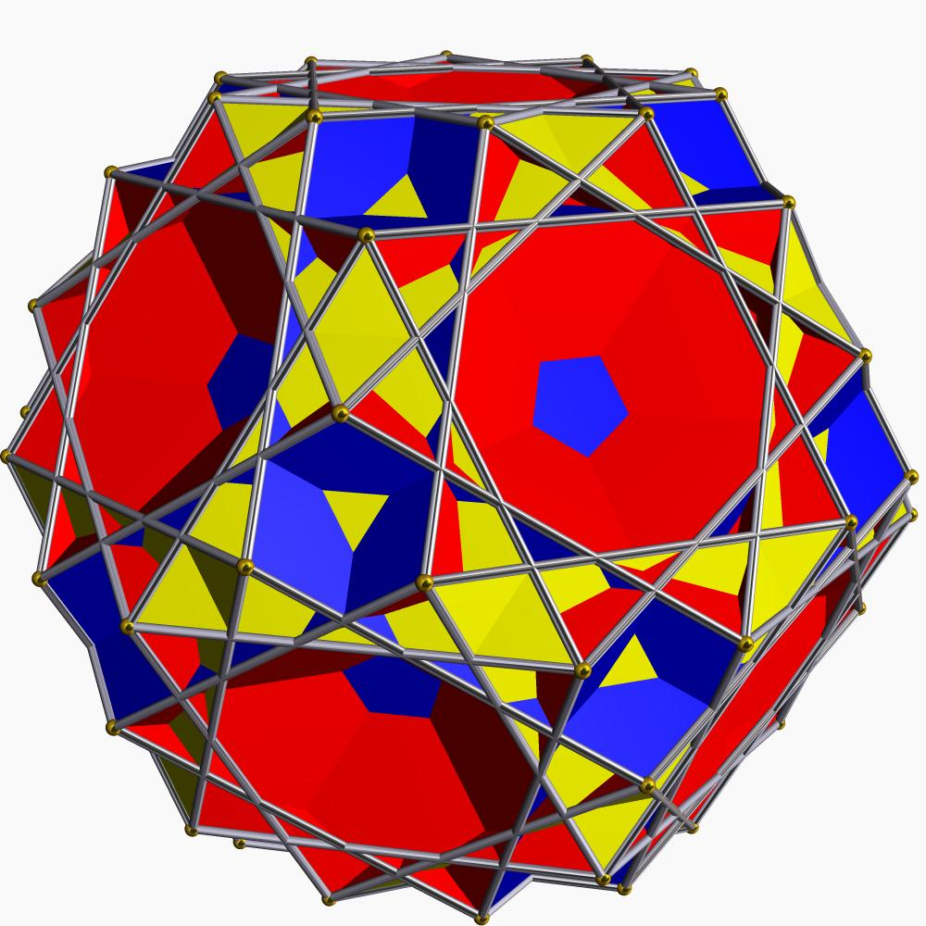

Geometric Structure
# Source: AI Source: Provided by: [Data Path: Persons Table -> ID Column: 1, Name_En Column: Motasem Essam] -> From: [ChatGPT] on [7/25/2026]
The Great Icosicosidodecahedron has the following structure:
- 20 equilateral triangular faces.
- 12 regular pentagonal faces.
- 20 regular hexagonal faces.
- Its faces intersect in space, producing a non-convex star-like structure.
- Its vertices and edges form a uniform arrangement with icosahedral symmetry.
Its polygonal faces are represented using:
- Triangle: $\{3\}$
- Pentagon: $\{5\}$
- Hexagon: $\{6\}$
Unlike some other uniform star polyhedra, its pentagonal faces are ordinary convex pentagons rather than pentagrams.

Mathematical Properties
# Source: AI Source: Provided by: [Data Path: Persons Table -> ID Column: 1, Name_En Column: Motasem Essam] -> From: [ChatGPT] on [7/25/2026]
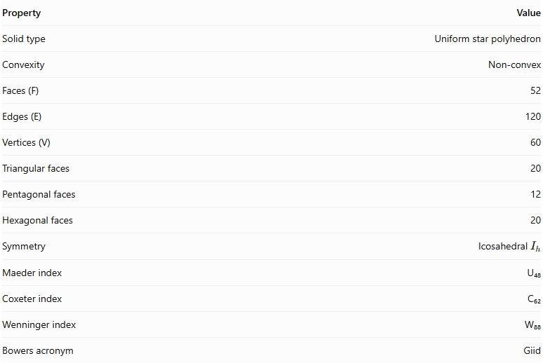
Property | Value
Solid type | Uniform star polyhedron
Convexity | Non-convex
Faces (F) | 52
Edges (E) | 120
Vertices (V) | 60
Triangular faces | 20
Pentagonal faces | 12
Hexagonal faces | 20
Symmetry | Icosahedral $I_{h}$
Maeder index | U₄₈
Coxeter index | C₆₂
Wenninger index | W₈₈
Bowers acronym | Giid

Face Composition
# Source: AI Source: Provided by: [Data Path: Persons Table -> ID Column: 1, Name_En Column: Motasem Essam] -> From: [ChatGPT] on [7/25/2026]
The solid contains three types of polygonal faces.
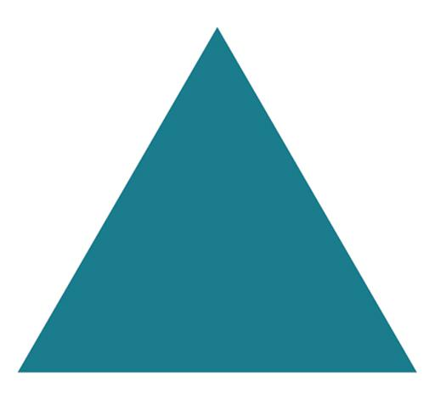

Triangles
# Source: AI Source: Provided by: [Data Path: Persons Table -> ID Column: 1, Name_En Column: Motasem Essam] -> From: [ChatGPT] on [7/25/2026]
3 sides each
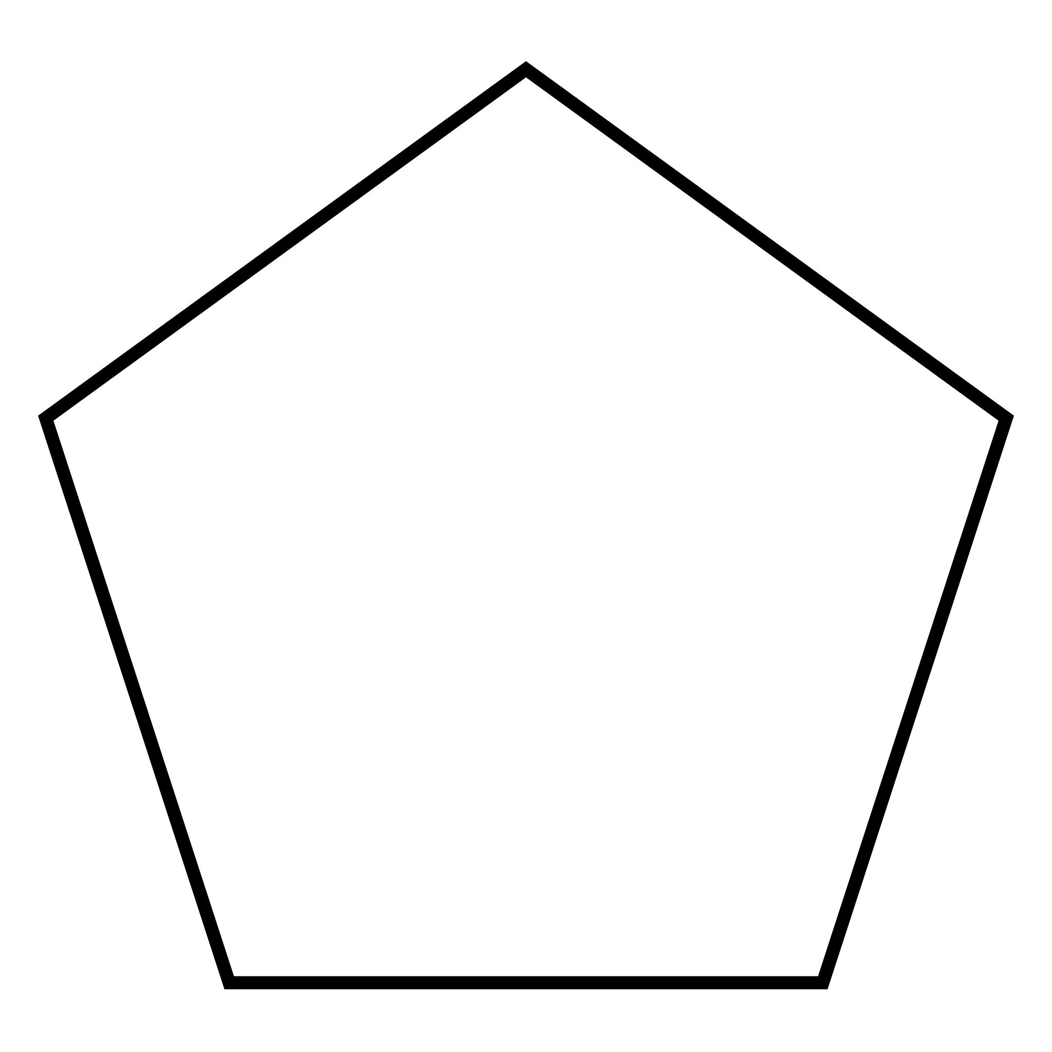

Pentagons
# Source: AI Source: Provided by: [Data Path: Persons Table -> ID Column: 1, Name_En Column: Motasem Essam] -> From: [ChatGPT] on [7/25/2026]
5 sides each
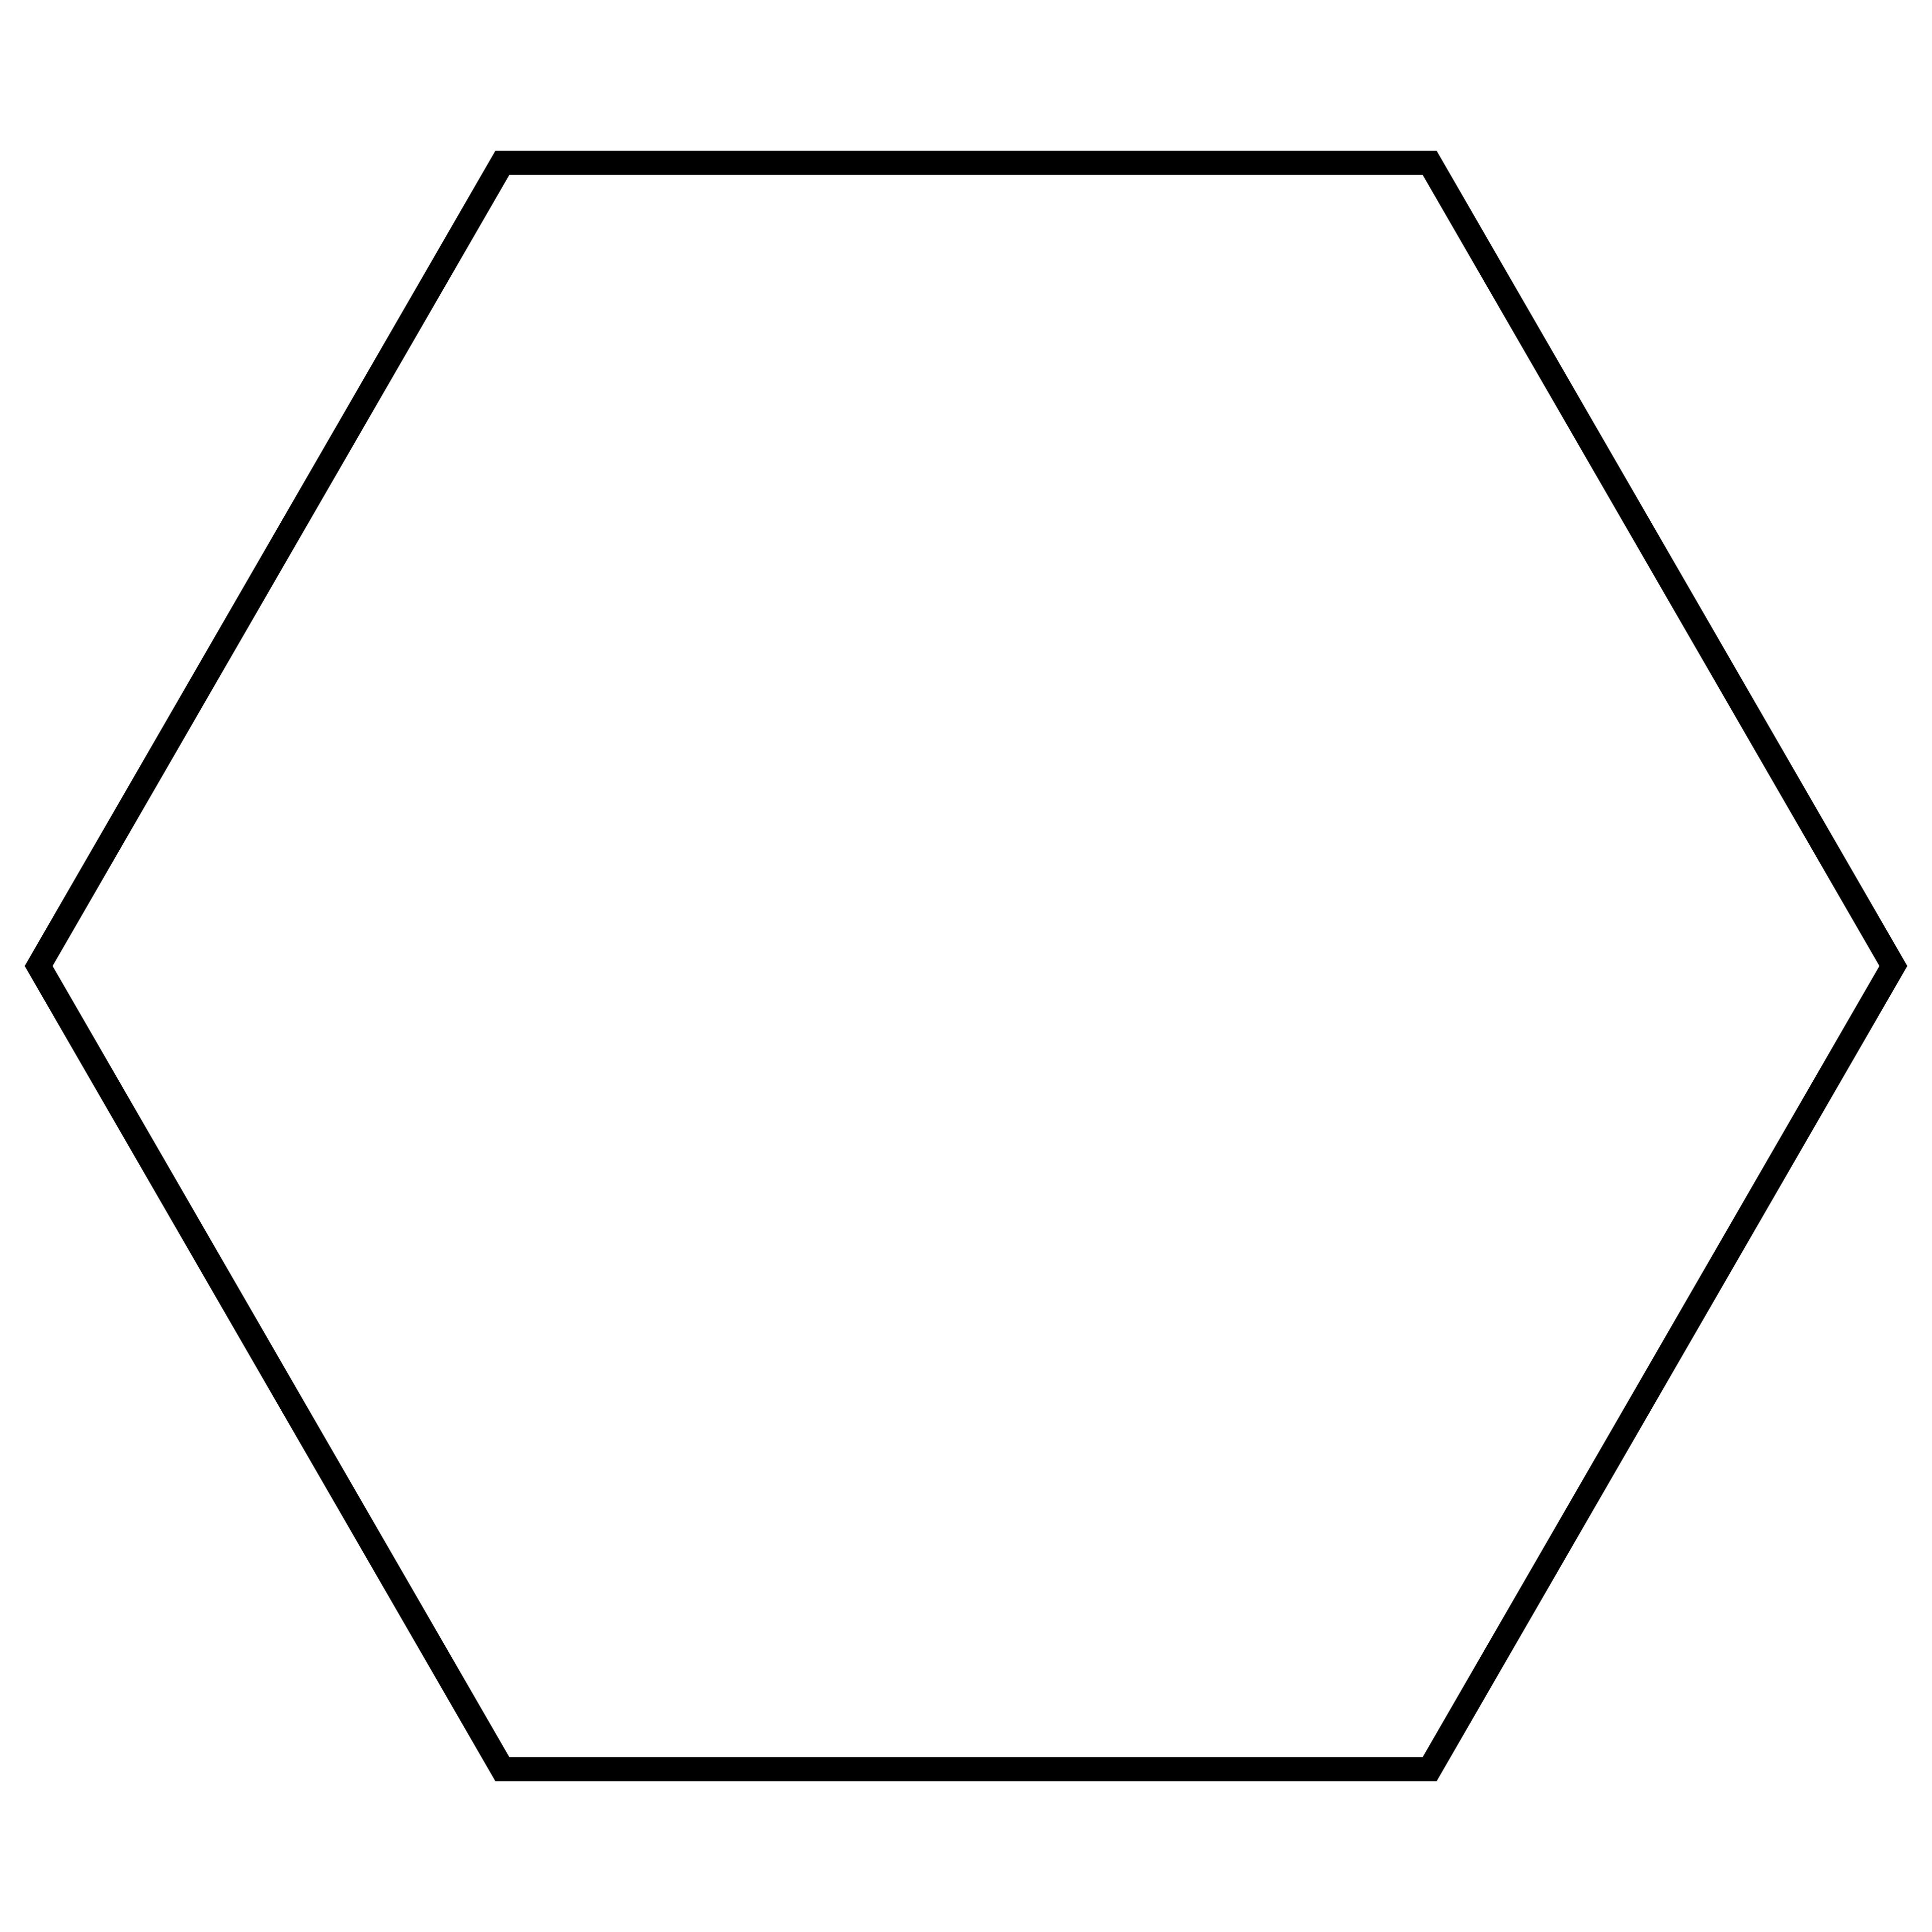

Hexagons
# Source: AI Source: Provided by: [Data Path: Persons Table -> ID Column: 1, Name_En Column: Motasem Essam] -> From: [ChatGPT] on [7/25/2026]
6 sides each
Total number of faces:
$$F=20+12+20=52$$
The face composition is written as:
$$20\{3\}+12\{5\}+20\{6\}$$

Vertex Configuration
# Source: AI Source: Provided by: [Data Path: Persons Table -> ID Column: 1, Name_En Column: Motasem Essam] -> From: [ChatGPT] on [7/25/2026]
The vertex configuration describes the sequence of polygonal faces surrounding each vertex.
For the Great Icosicosidodecahedron, the configuration is:
$$6.5.\frac{3}{2}.6$$
This indicates the local arrangement of a hexagonal face, a pentagonal face, a triangular face, and another hexagonal face around each vertex. The $\frac{3}{2}$ notation is part of the star-polyhedron vertex-configuration convention.
Its vertex figure is a crossed quadrilateral, reflecting the non-convex arrangement of faces around each vertex.

Construction
# Source: AI Source: Provided by: [Data Path: Persons Table -> ID Column: 1, Name_En Column: Motasem Essam] -> From: [ChatGPT] on [7/25/2026]
The Great Icosicosidodecahedron is generated through a Wythoff construction based on icosahedral symmetry.
Its Wythoff symbol is:
$$\frac{3}{2} 5∣3$$
This construction produces the uniform arrangement of triangular, pentagonal, and hexagonal faces.

Geometric Dimensions and Formulas
# Source: AI Source: Provided by: [Data Path: Persons Table -> ID Column: 1, Name_En Column: Motasem Essam] -> From: [ChatGPT] on [7/25/2026]
For a uniform model with edge length $a$, the individual face areas are:
Equilateral triangle
$$A_{3}=\frac{\sqrt{3}}{4}a^{2}$$
Regular pentagon
$$A_{5}=\frac{1}{4}\sqrt{25+10\sqrt{5}} a^{2}$$
Regular hexagon
$$A_{6}=\frac{3\sqrt{3}}{2}a^{2}$$
The sum of the individual polygonal face areas is:
$$A_{faces}=20A_{3}+12A_{5}+20A_{6}$$
Substituting:
$$A_{faces}=5\sqrt{3}a^{2}+3\sqrt{25+10\sqrt{5}} a^{2}+30\sqrt{3}a^{2}$$
Therefore:
$$\boxed{A_{faces}=(35\sqrt{3}+3\sqrt{25+10\sqrt{5}})a^{2}}$$
This is the sum of the areas of the individual polygonal faces, not necessarily the exposed boundary area of the intersecting solid.
Circumradius
For unit edge length, its circumradius is:
$$R=\frac{1}{4}\sqrt{34-6\sqrt{5}}$$
For edge length $a$:
$$\boxed{R=\frac{a}{4}\sqrt{34-6\sqrt{5}}}$$

Euler Characteristic
# Source: AI Source: Provided by: [Data Path: Persons Table -> ID Column: 1, Name_En Column: Motasem Essam] -> From: [ChatGPT] on [7/25/2026]
The Euler characteristic is calculated using:
$$χ=V-E+F$$
Substituting the solid's elements:
$$χ=60-120+52$$
$$\boxed{χ=-8}$$
For a connected, closed, orientable abstract surface, this corresponds to genus:
$$g=\frac{2-χ}{2}$$
$$\boxed{g=5}$$
This is a topological interpretation of the abstract surface structure, not a description of the solid's interior.

Symmetry
# Source: AI Source: Provided by: [Data Path: Persons Table -> ID Column: 1, Name_En Column: Motasem Essam] -> From: [ChatGPT] on [7/25/2026]
The Great Icosicosidodecahedron has icosahedral symmetry.
Its full symmetry group is:
$$I_{h}$$
This includes rotational and reflectional symmetries associated with the icosahedral group.

Constructing a Great Icosicosidodecahedron

Geometric Instruments
# Source: AI Source: Provided by: [Data Path: Persons Table -> ID Column: 1, Name_En Column: Motasem Essam] -> From: [ChatGPT] on [7/25/2026]
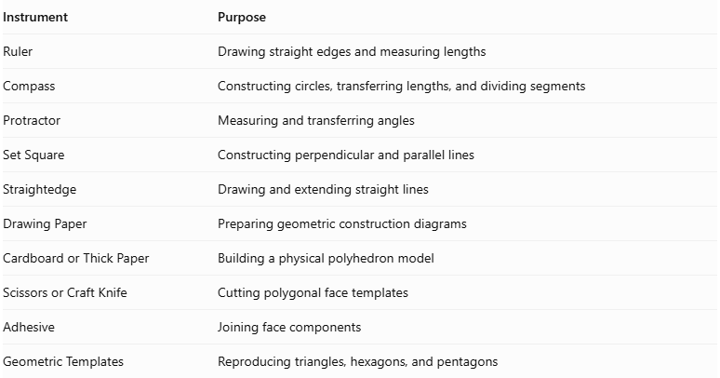
Instrument | Purpose
Ruler | Drawing straight edges and measuring lengths
Compass | Constructing circles, transferring lengths, and dividing segments
Protractor | Measuring and transferring angles
Set Square | Constructing perpendicular and parallel lines
Straightedge | Drawing and extending straight lines
Drawing Paper | Preparing geometric construction diagrams
Cardboard or Thick Paper | Building a physical polyhedron model
Scissors or Craft Knife | Cutting polygonal face templates
Adhesive | Joining face components
Geometric Templates | Reproducing triangles, hexagons, and pentagons

Instrument-Based Construction Procedures

Method 1: Construction from a Truncated Dodecahedron Vertex Framework
# Source: AI Source: Provided by: [Data Path: Persons Table -> ID Column: 1, Name_En Column: Motasem Essam] -> From: [ChatGPT] on [7/25/2026]
The Great Icosicosidodecahedron shares its vertex arrangement with the truncated dodecahedron. This makes the truncated dodecahedron a useful geometric reference for establishing the 60 vertex positions. However, the face connections must be rearranged to produce the Great Icosicosidodecahedron.
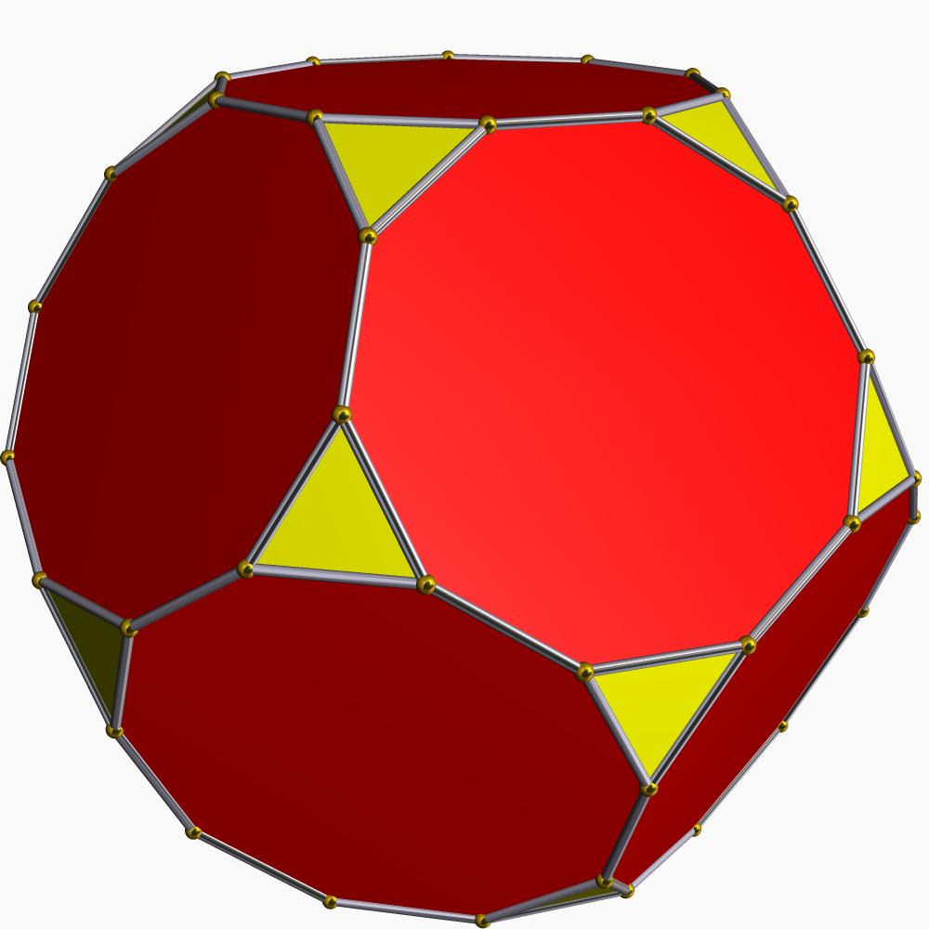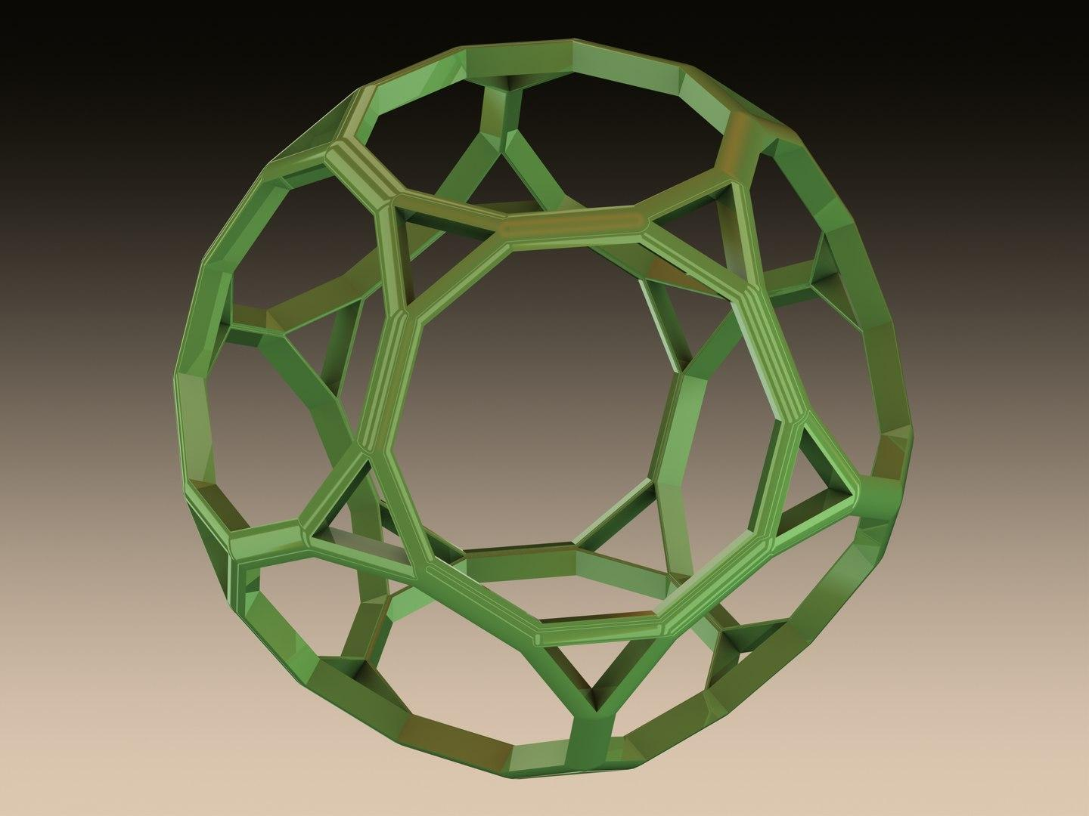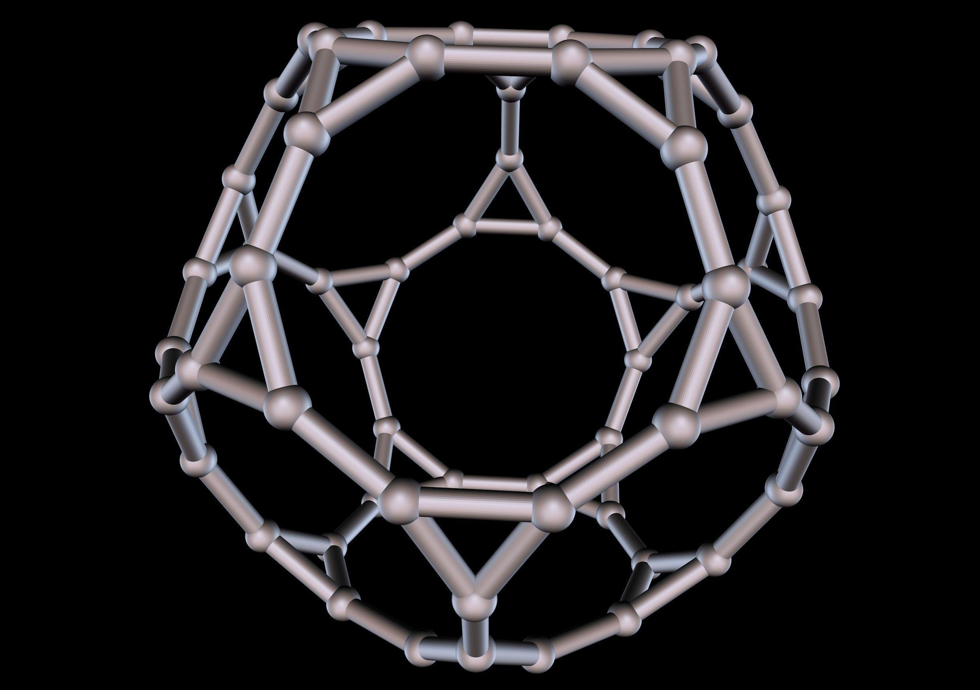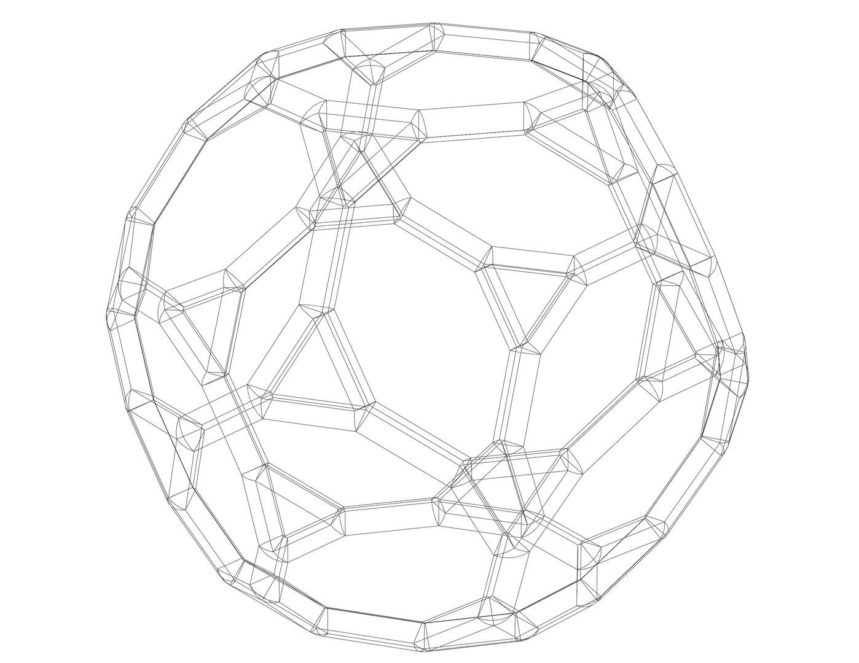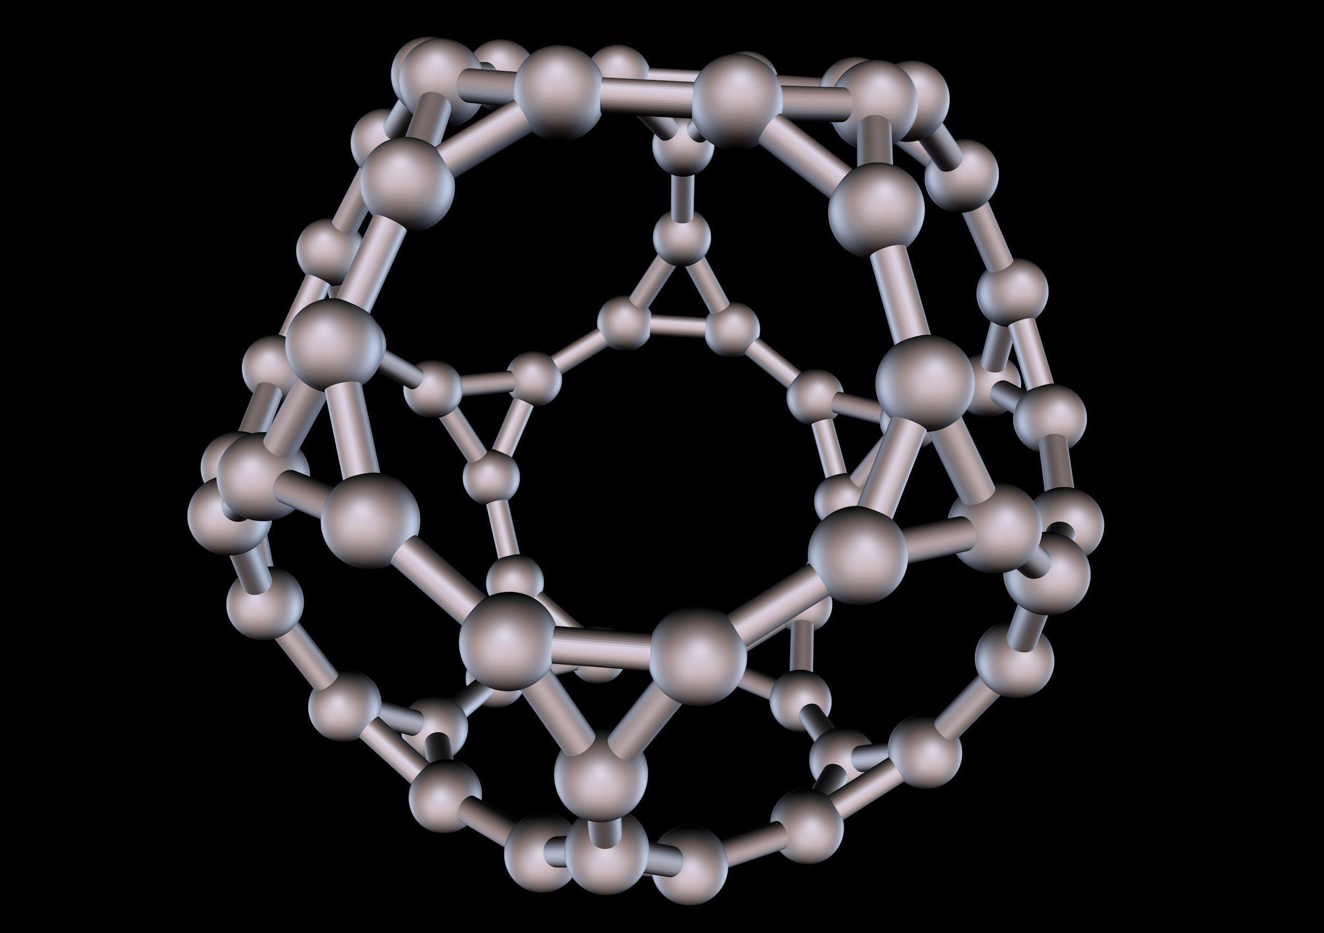
Step 1: Construct a Regular Dodecahedron
- Draw a regular pentagon using a ruler and compass.
- Establish the regular pentagonal face arrangement.
- Use repeated geometric construction to form a regular dodecahedron.
- Mark its 20 original vertices.
Step 2: Construct the Truncated Dodecahedron Framework
- Identify the five edges meeting at each original dodecahedron vertex.
- Mark the truncation positions along these edges.
- Use equal divisions and transferred lengths to establish consistent truncation.
- Connect the marked points to form the truncated-dodecahedron framework.
- Identify the resulting 60 vertices.
Step 3: Preserve the Vertex Arrangement
- Retain all 60 vertex positions.
- Mark the icosahedral symmetry-related groups.
- Use a compass to check corresponding distances.
- Do not assume that the truncated dodecahedron's original face connections are the required final connections.
Step 4: Establish the Great Icosicosidodecahedron Edge Network
- Identify the 120 required edges.
- Connect the vertices according to the Great Icosicosidodecahedron's uniform arrangement.
- Use a ruler to draw the edge network.
- Preserve the crossed local arrangements where face regions intersect.
Step 5: Identify the Face Groups
- Identify 20 groups of three vertices forming triangular faces.
- Identify 20 groups of six vertices forming hexagonal faces.
- Identify 12 groups of five vertices forming pentagonal faces.
- Connect each group in its appropriate cyclic order.
Step 6: Complete the Solid
- Distinguish the actual polyhedron edges from apparent crossing lines.
- Verify the face arrangements from multiple viewing directions.
- Check that the completed framework has 60 vertices and 120 edges.

Method 2: Construction Using Polygonal Face Templates
# Source: AI Source: Provided by: [Data Path: Persons Table -> ID Column: 1, Name_En Column: Motasem Essam] -> From: [ChatGPT] on [7/25/2026]
This method is useful for constructing a physical paper or cardboard model.
Step 1: Prepare the Triangular Face Templates
- Construct an equilateral triangle with side length $a$.
- Use a compass to transfer the same length to all three sides.
- Verify that each interior angle is ${60}^{°}$.
- Prepare 20 copies.
Step 2: Prepare the Hexagonal Face Templates
- Construct a regular hexagon with side length $a$.
- Draw a circle and use the compass to transfer the side length six times around its circumference.
- Connect the six consecutive vertices.
- Verify that each interior angle is ${120}^{°}$.
- Prepare 20 copies.
Step 3: Prepare the Pentagonal Face Templates
- Construct a regular pentagon with side length $a$.
- Divide the circumference into five equal parts using compass constructions.
- Connect the consecutive vertices.
- Verify that each interior angle is ${108}^{°}$.
- Prepare 12 copies.
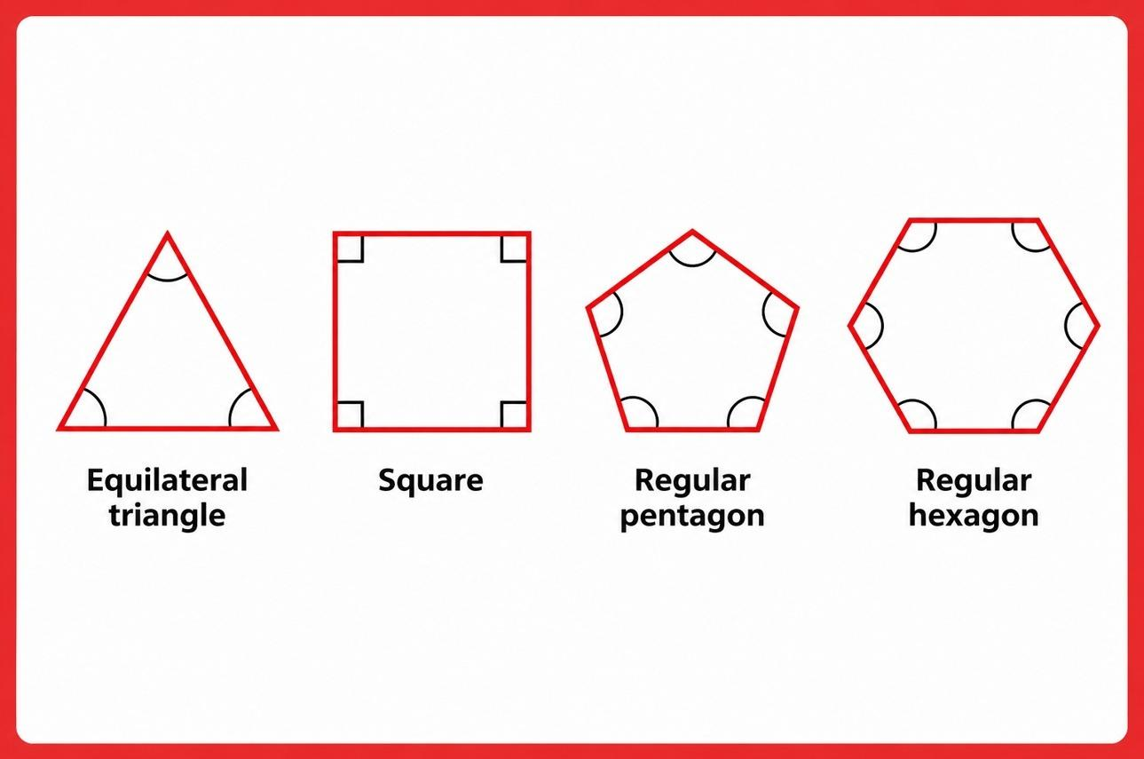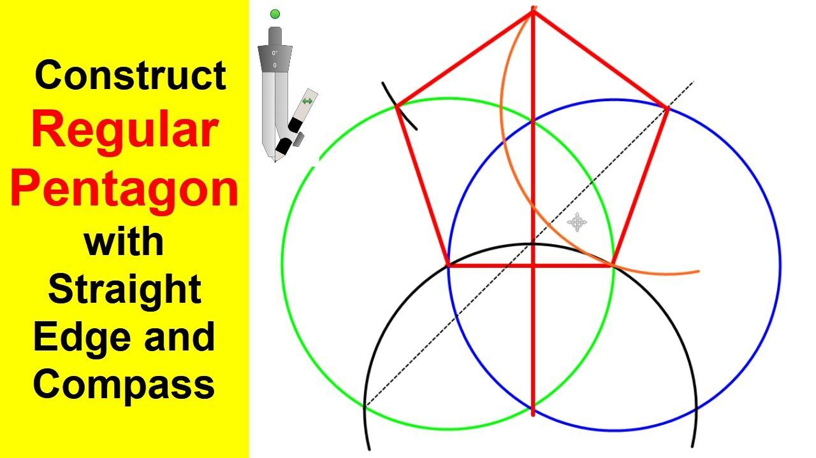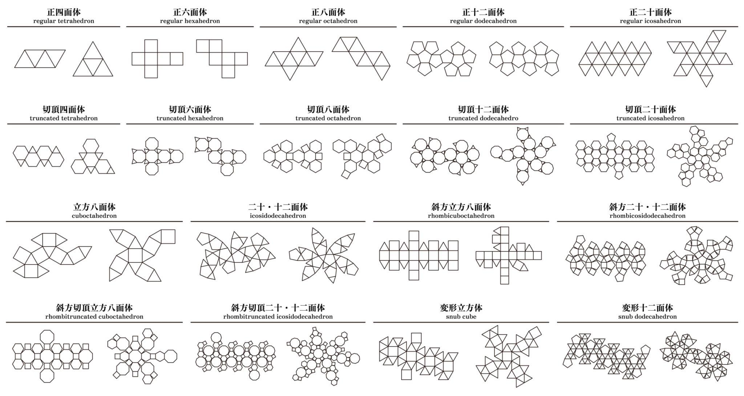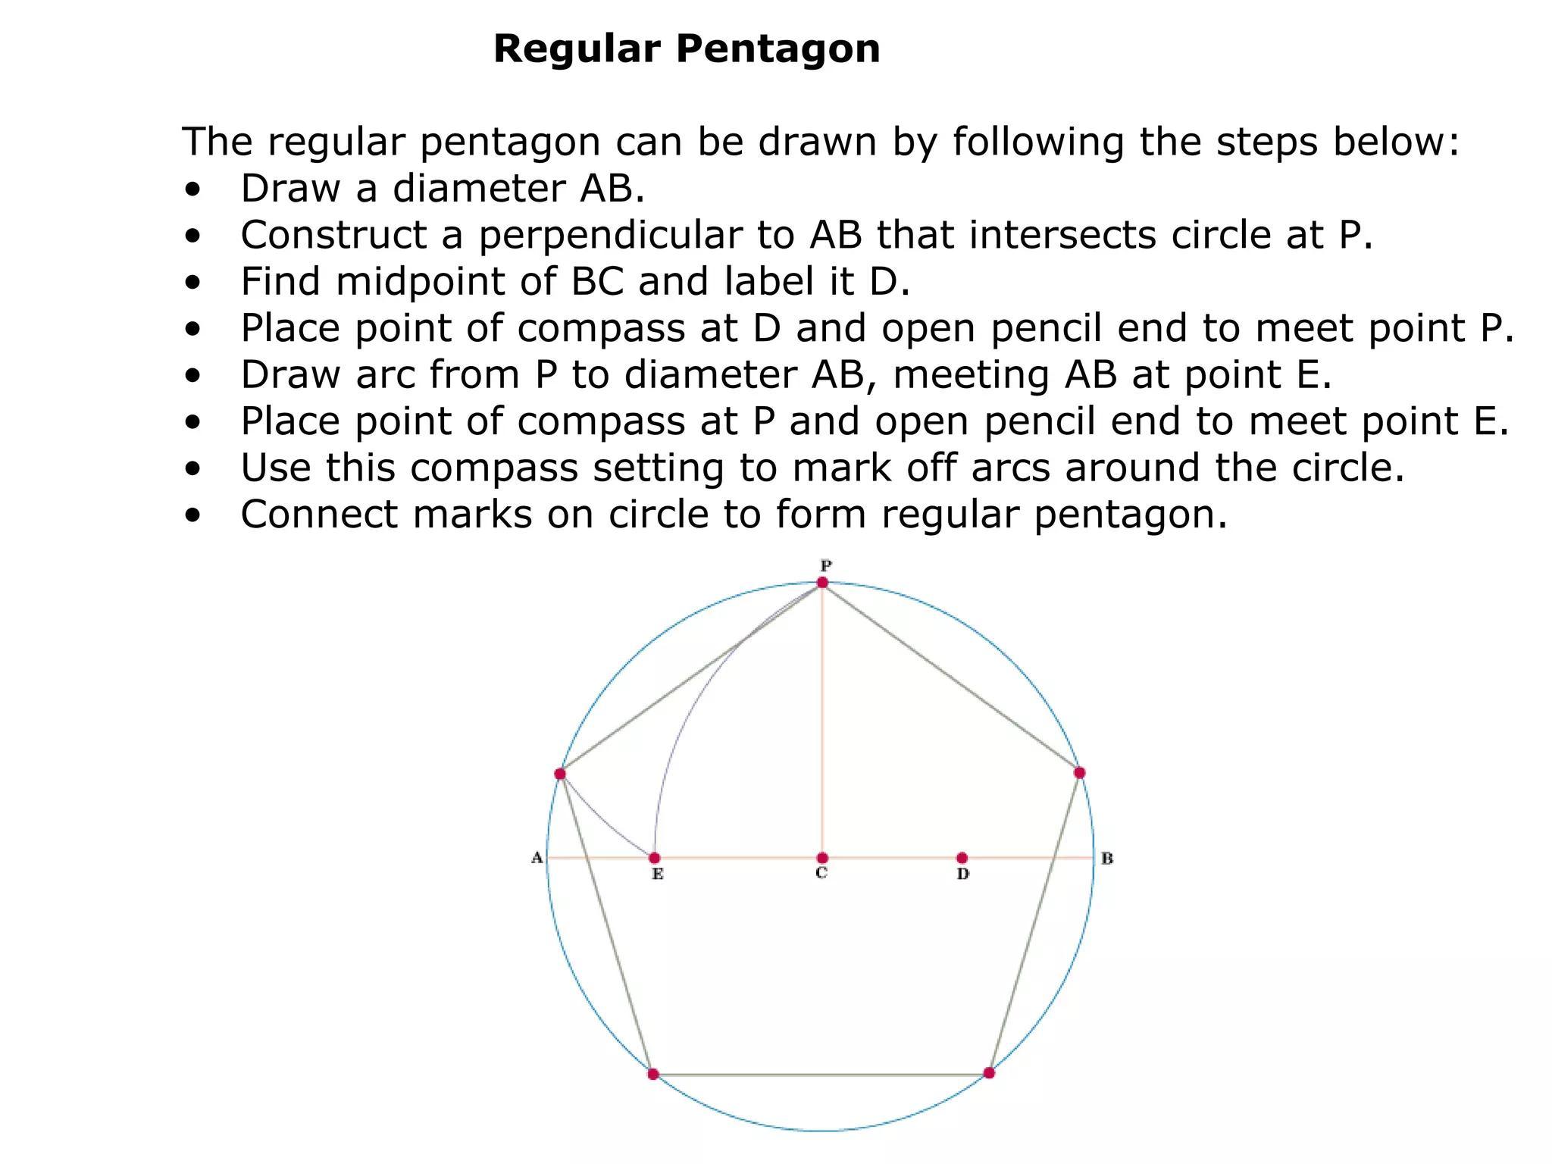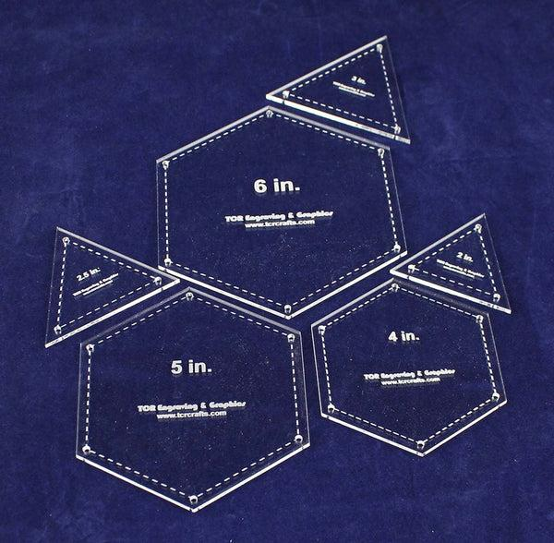
Step 4: Establish the Common Edge Length
- Use the same edge length $a$ for all three face types.
- Compare the sides using a compass.
- Correct any differences before assembly.
Step 5: Arrange the Face Templates
- Use an icosahedrally symmetric reference framework.
- Position the 20 triangles, 20 hexagons, and 12 pentagons.
- Follow the required vertex configuration.
- Preserve the non-convex face arrangement rather than assembling the templates as an ordinary convex polyhedron.
Step 6: Assemble the Model
- Cut out the face templates.
- Use tabs or suitable connectors to join corresponding edges.
- Maintain the required face intersections.
- Inspect the completed structure from multiple directions.
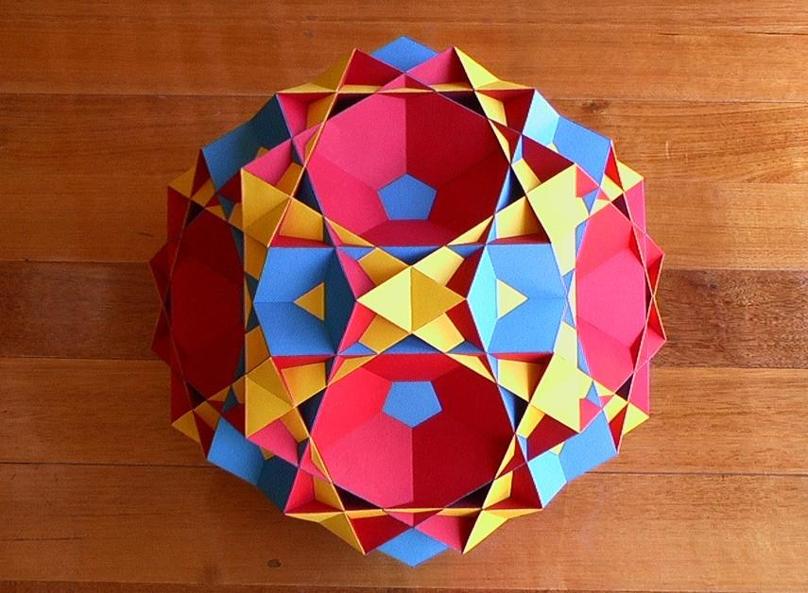

Method 3: Construction Using Icosahedral Symmetry and Wythoff Geometry
# Source: AI Source: Provided by: [Data Path: Persons Table -> ID Column: 1, Name_En Column: Motasem Essam] -> From: [ChatGPT] on [7/25/2026]
The Great Icosicosidodecahedron has the Wythoff symbol:
$$\frac{3}{2} 5∣3$$
This method uses the symmetry of the icosahedral reflection arrangement to establish the uniform vertex and face structure.
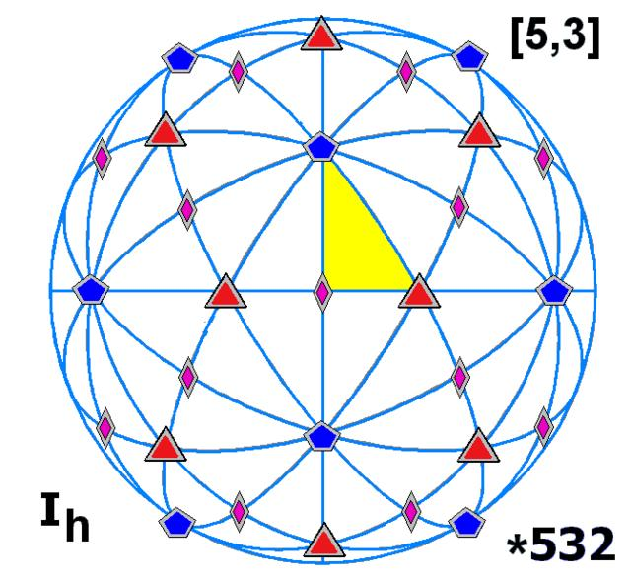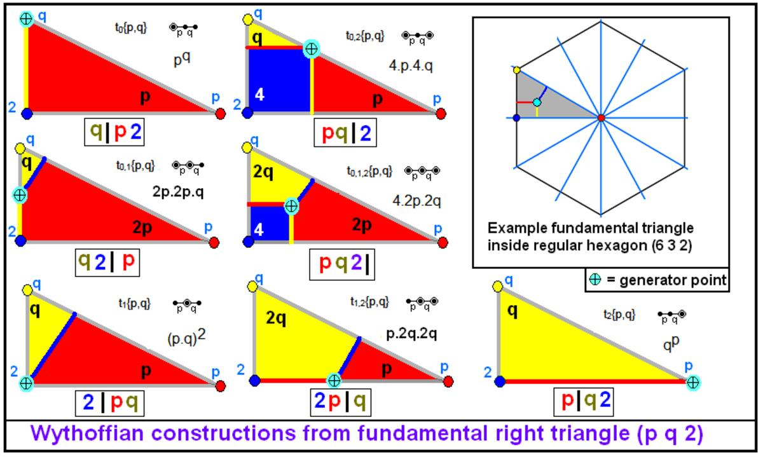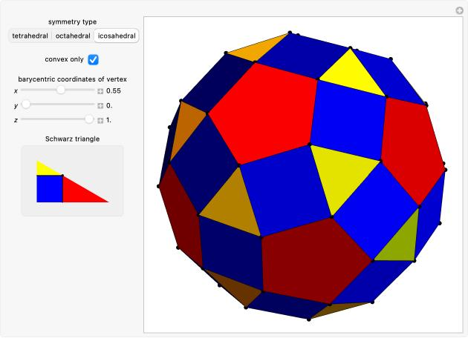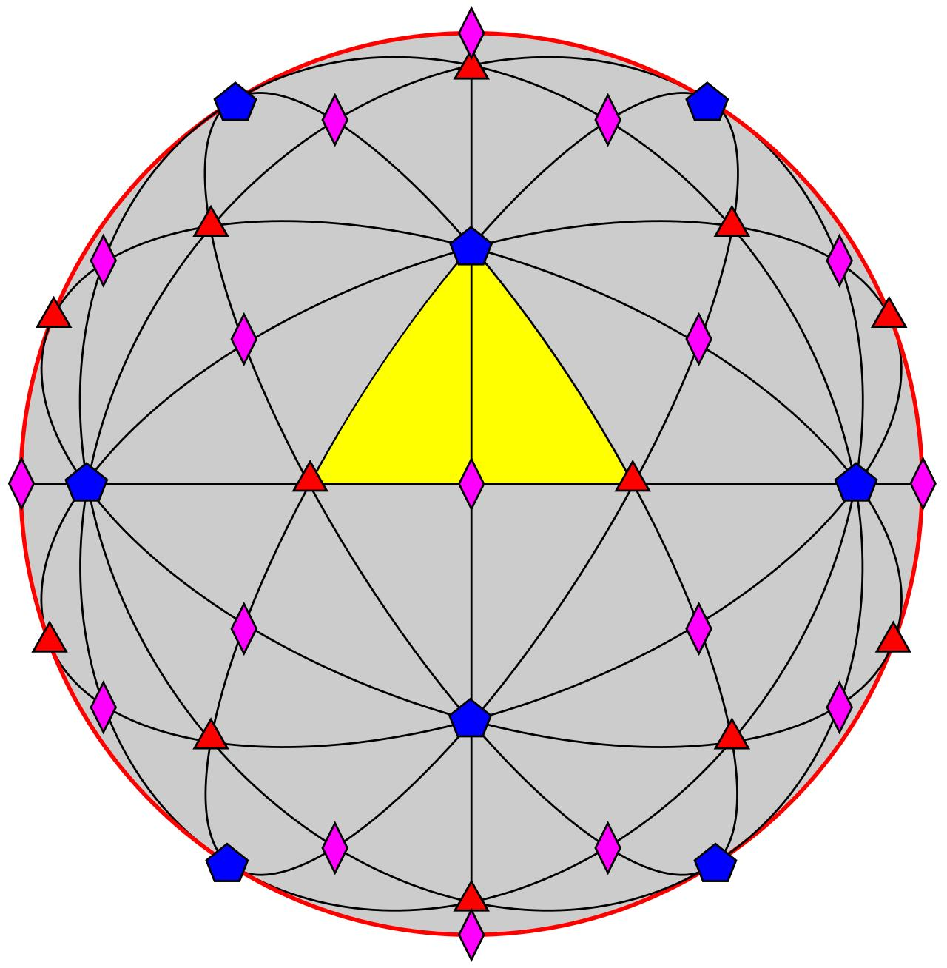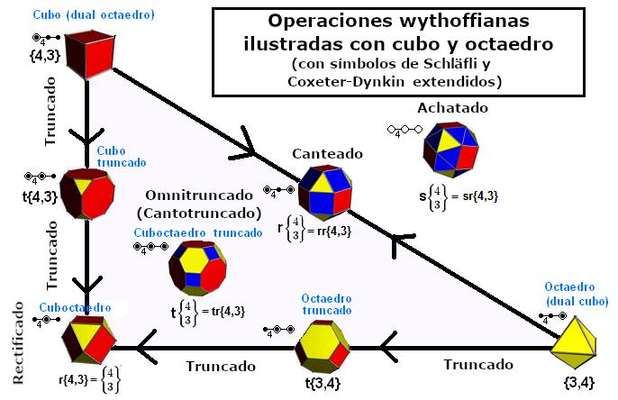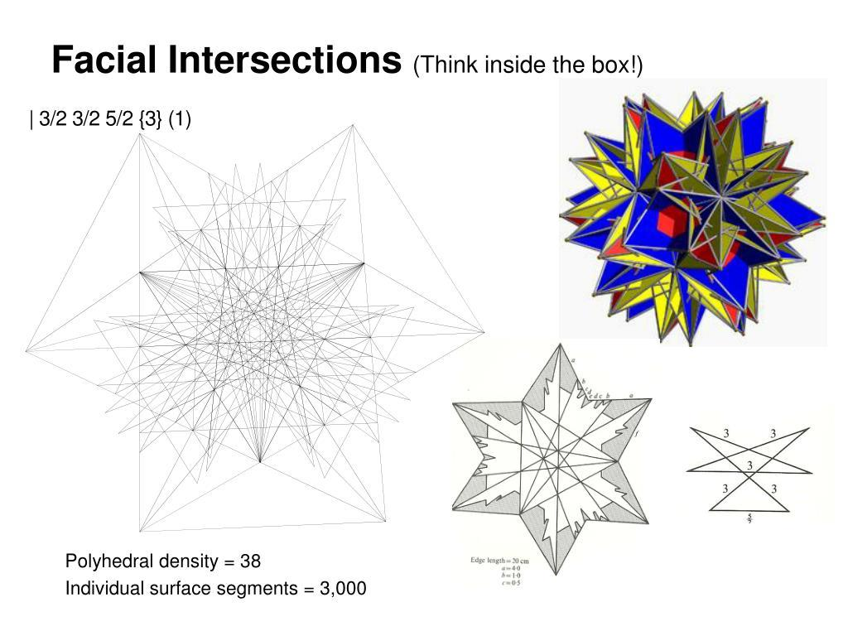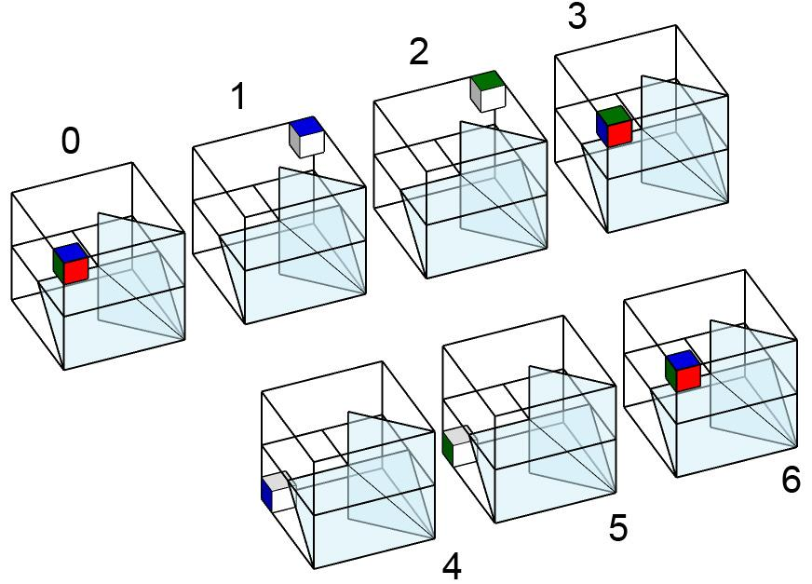
Step 1: Establish the Icosahedral Symmetry Framework
- Construct a regular pentagonal reference arrangement.
- Identify the fivefold symmetry direction.
- Establish the associated threefold and twofold symmetry directions.
- Use repeated geometric reflections to develop the symmetry framework.
Step 2: Construct the Fundamental Reflection Regions
- Draw the required symmetry reference lines.
- Use a protractor to transfer the angular relationships.
- Construct the reflection boundaries with a ruler.
- Mark the fundamental region used for the Wythoff arrangement.
Step 3: Establish the Wythoff Starting Position
- Use the Wythoff symbol $\frac{3}{2} 5∣3$ to identify the required reflection arrangement.
- Mark the appropriate starting position relative to the fundamental region.
- Use compass-based distance transfer to establish the corresponding vertex positions.
Step 4: Generate the Symmetry-Related Vertices
- Reflect the starting construction through the symmetry arrangement.
- Repeat the construction throughout the icosahedral framework.
- Establish the complete set of 60 vertices.
Step 5: Construct the Faces and Edges
- Connect the vertices to form the 20 triangles.
- Construct the 20 hexagons.
- Construct the 12 pentagons.
- Preserve the crossed local vertex arrangement.
Step 6: Verify the Completed Polyhedron
- Check all 52 faces.
- Check all 120 edges.
- Check all 60 vertices.
- Verify the icosahedral symmetry.
Construction note: A complete Wythoff construction requires the exact fundamental reflection geometry and starting-point placement. The symbol alone does not provide sufficient measurements to construct the solid accurately.

Relationship to Other Geometric Solids
# Source: AI Source: Provided by: [Data Path: Persons Table -> ID Column: 1, Name_En Column: Motasem Essam] -> From: [ChatGPT] on [7/25/2026]
Dual Polyhedron
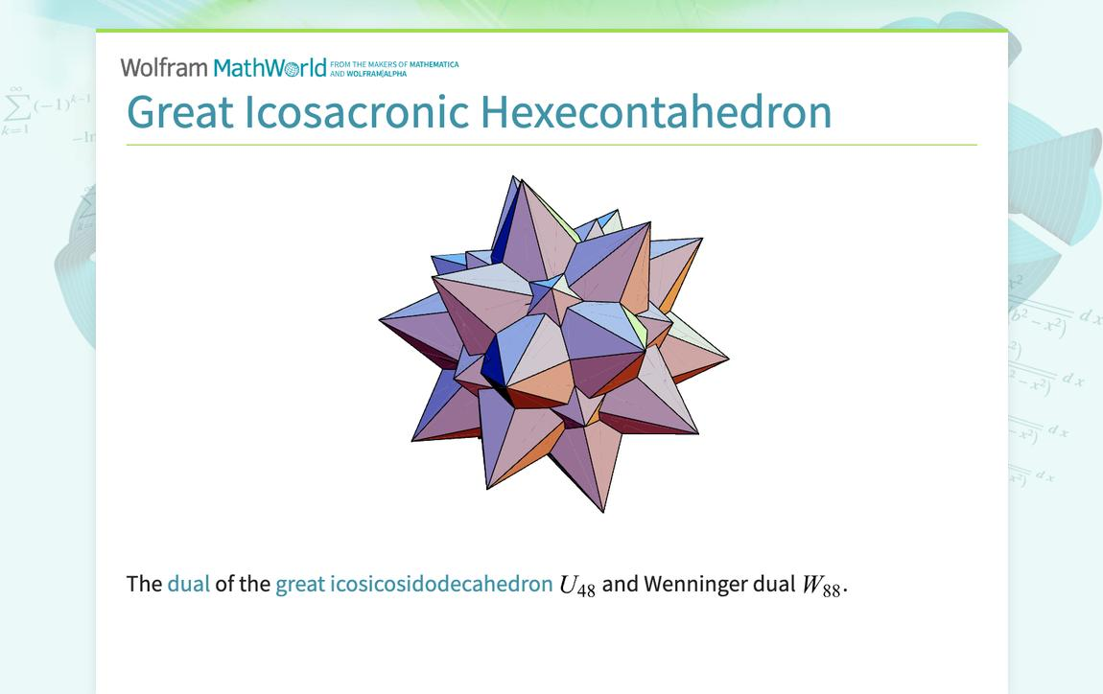
Great Icosacronic Hexecontahedron
The dual of the Great Icosicosidodecahedron. Its vertices correspond to the faces of the original polyhedron, while its faces correspond to the original vertices.
Related Polyhedra
- Truncated Dodecahedron: Shares the same vertex arrangement.
- Great Ditrigonal Dodecicosidodecahedron: Shares its triangular and pentagonal face arrangement.
- Great Dodecicosahedron: Shares its hexagonal face arrangement.

Comparison with Related Solids
# Source: AI Source: Provided by: [Data Path: Persons Table -> ID Column: 1, Name_En Column: Motasem Essam] -> From: [ChatGPT] on [7/25/2026]
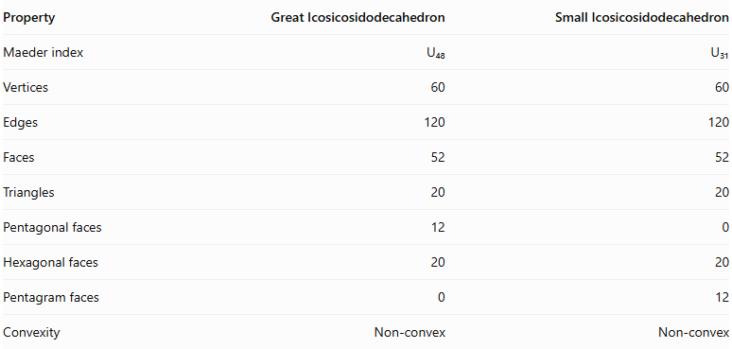
Property | Great Icosicosidodecahedron | Small Icosicosidodecahedron
Maeder index | U₄₈ | U₃₁
Vertices | 60 | 60
Edges | 120 | 120
Faces | 52 | 52
Triangles | 20 | 20
Pentagonal faces | 12 | 0
Hexagonal faces | 20 | 20
Pentagram faces | 0 | 12
Convexity | Non-convex | Non-convex
The main distinction is the pentagonal face type: the Great Icosicosidodecahedron has ordinary pentagons, whereas the Small Icosicosidodecahedron has pentagrams $\{5/2\}$.

Main Classification
# Source: AI Source: Provided by: [Data Path: Persons Table -> ID Column: 1, Name_En Column: Motasem Essam] -> From: [ChatGPT] on [7/25/2026]
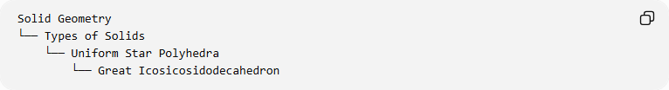
Solid Geometry
└── Types of Solids
└── Uniform Star Polyhedra
└── Great Icosicosidodecahedron

Key Points
# Source: AI Source: Provided by: [Data Path: Persons Table -> ID Column: 1, Name_En Column: Motasem Essam] -> From: [ChatGPT] on [7/25/2026]
- The Great Icosicosidodecahedron is a non-convex uniform star polyhedron.
- It has 52 faces, 120 edges, and 60 vertices.
- Its faces consist of 20 triangles, 12 pentagons, and 20 hexagons.
- Its Wythoff symbol is $\frac{3}{2} 5∣3$.
- Its symmetry group is $I_{h}$.
- It is classified as U₄₈.
- Its dual is the Great Icosacronic Hexecontahedron.
- Its Euler characteristic is $-8$.

Conclusion
# Source: AI Source: Provided by: [Data Path: Persons Table -> ID Column: 1, Name_En Column: Motasem Essam] -> From: [ChatGPT] on [7/25/2026]
The Great Icosicosidodecahedron is a complex uniform star polyhedron distinguished by its combination of triangular, pentagonal, and hexagonal faces. Its icosahedral symmetry, intersecting geometry, and relationship to several other uniform polyhedra make it an important member of the uniform star polyhedra classification.

